**Target Journal: Environmental Research Letters**

**Single or double anonymous (author choice)**

**Title**

A quantitative health impact assessment of urban greenspace and all-cause mortality across 1,041 global cities

*The title should be concise, informative and meaningful to the whole readership of the journal. It should include key terms, to help make it more discoverable when people search online. Please avoid the use of long systemic names and non-standard or obscure abbreviations, acronyms or symbols.*

**Authors**

Greta K. Martin1, Patrick L. Kinney2, Jennifer D. Stowell2, Susan C. Anenberg1

1The George Washington University Milken Institute of Public Health, Washington, DC

2Boston University School of Public Health, Boston, MA

*Check the*[*peer review model*](https://publishingsupport.iopscience.iop.org/questions/peer-review-models-on-iop-journals/)*for the journal you are submitting to when preparing the PDF version of your manuscript. If****double-anonymous****then you will need to [anonymise your manuscript](https://publishingsupport.iopscience.iop.org/questions/checklist-for-anonymising-your-manuscript/). If****single-anonymous****then you need to list all authors’ full names and institutions. During the submission process, we recommend you supply*[*ORCID*](https://publishingsupport.iopscience.iop.org/questions/structure-and-format-of-your-journal-article/publishingsupport.iopscience.iop.org/orcid/)*identifiers for all authors to avoid ambiguity. We encourage authors to make specific attributions of contribution and responsibility in the acknowledgements of the article, otherwise all co-authors will be taken to share full responsibility for all of the paper. Authors may wish to use a taxonomy such as [CRediT](http://credit.niso.org/) to describe the contributions of each author. More guidance on authorship, including the responsibilities of the corresponding author, can be found*[*here*](https://publishingsupport.iopscience.iop.org/questions/ethics-of-authorship/)*.*

**Keywords**

Health impact assessment, greenspace, blue space, Normalized Difference Vegetation Index, NDVI, urban nature

*When you submit an article, you will be asked to supply some keywords relevant to your work. If your article is accepted for publication, we will display these keywords on the published article, and they will be used to index your article, helping to make it more discoverable. When choosing keywords, think about the kinds of terms you would use when searching online for related articles.*

**Abstract**

*Your abstract should give readers a brief summary of your article. It should concisely describe the contents of your article, and include key terms (especially in the first two sentences, to increase search engine discoverability). It should be informative, accessible and not only indicate the general aims and scope of the article, but also state the methodology used, main results obtained and conclusions drawn. The abstract should be complete in itself; it should not contain undefined acronyms/abbreviations and no table numbers, figure numbers, references or equations should be referred to. Articles relying on clinical trials should quote the trial registration number at the end of the abstract. The abstract should be suitable for direct inclusion in abstracting services and should not normally be more than 300 words. If you submit an article with an abstract longer than 300 words, we may rescind the manuscript and ask you to re-write it. Some journals ask for abstracts to follow a particular structure. Check the*[*instructions for specific journals*](https://publishingsupport.iopscience.iop.org/journals/)*to see if you need to submit a structured abstract.*

**Introduction**

*This should be concise and describe the nature of the problem under investigation and its background. It should also set your work in the context of previous research, citing relevant references. Introductions should expand on highly specialised terms and abbreviations used in the article to make it accessible for readers.*

Over half of the world’s population lives in cities and this share is predicted to grow to two-thirds by 2050 1.Urbanization has been accompanied by the pollution of natural resources and destruction of natural environments. It is estimated that cities are responsible for over 80% of global greenhouse gas emissions 2. Although cities are the biggest contributors to climate change, they can also be effective entities of change. Cities can provide a large enough scale to create meaningful change while remaining small enough to test policies that might not be feasible at a national scale. City-level interventions to increase urban nature offer a climate adaptation strategy with health advantages.

The most common metric used to quantify greenspace in the health literature is the normalized difference vegetation index (NDVI)9. NDVI is a satellite-derived measure that uses visible and near infrared light to quantify the density of vegetation. NDVI ranges from -1 to 1, with negative values indicating water, snow, and ice, values near zero representing limited vegetation (e.g. urban areas, barren land), and positive values signifying vegetation.10 While most health studies use NDVI to measure greenspace, many urban greenspace policy goals are better classified with landcover datasets. Landcover maps classify each unit of land into discrete categories such as forests or shrublands. Because NDVI is not a commonly known metric outside of the scientific literature, these broad classifications can provide a more intuitive understanding of nature and align more closely with many urban nature policies focusing on expanding the amount or accessibility of greenspaces. However, NDVI can capture small scale urban greenspaces such as tree-lined streets or small parks, which can be missed by landcover maps. Additionally, NDVI is derived from satellite imagery, which is updated as frequently as every 8 days, allowing for better characterization of longitudinal exposures. We provide estimates of greenspace in terms of both NDVI and the proportion of green and green and blue area.

Two studies estimating the number of deaths associated with hypothetical changes in greenspace in European and American cities indicate that…. . A 2021 study of 978 cities in 31 European countries found that if cities were to increase their NDVI to a level equivalent with the World Health Organization’s recommendation of universal access to greenspace, 42,968 natural deaths could be avoided annually (95% CI: 32,296, 64,177) among adults 11. A 2022 study of the 35 most populous American cities found that if NDVI was increased by 0.1, 38,000 deaths (95% CI: 28,640-57,281) could have been avoided in 2019 among those aged 65 years and older 12. These studies provide a useful quantification of the potential health benefits of increasing urban nature but are limited to European and American contexts.

In 2020, The Lancet Countdown began tracking urban greenspace across a global set of cities. The Lancet Countdown is an annual publication dedicated to tracking progress towards the goals of the Paris Agreement and documenting the health implications of climate change.13 We use the Lancet Countdown’s estimates of urban greenspace to conduct a health impact assessment of the excess or avoided deaths associated with changes in greenspace over time across 1,041 global cities. While the climate resiliency benefits of increasing urban greenspace are dependent on extreme weather events, the health benefits of such policies are more fixed. Quantifying the health benefits can therefore serve as an impetus to increase greenspace, as these advantages have a more immediate and certain pay-off. Our analysis quantifies changes in urban greenspace over time across a global set of cities. The results of this study can be used to compare greenspace across cities and over time to make health-centered decisions around urban environmental hazards.

**Methods**

*This section should provide sufficient details of the experiment, simulation, statistical test or analysis carried out to generate the results such that the method can be repeated by another researcher and the results reproduced.*

We estimated urban greenspace using green and blue space in 2020, as well as the population-weighted greenest-season normalized difference vegetation index (NDVI) from 2014 to 2023, in 1,041 cities across 174 countries. We then estimated the mortality change in each city associated with NDVI changes between two five-year periods, from 2014-2018 to 2019-2023. We defined urban extents using the Global Human Settlement Urban Centre Database (GHS-UCDB), which provides a consistent methodology based on population and remote sensing data.14 Cities were included if they were the most populous in their country or had over 500,000 inhabitants. Twenty-two countries did not have cities in the GHS-UCDB and were not represented in the analysis.

*Green and green and blue area*

The percent green and green or blue space metrics were calculated from NASA’s Modis satellite, which we accessed through Google Earth Engine (GEE). This dataset is available yearly and provides various landcover classifications for each 500m pixel. We used the 2020 University of Maryland (UMD) classification. We first created binary indicators of: 1) greenspace, which included pixels classified as forests, shrublands, savannas, grasslands, and croplands, and 2) green or blue space, which included these categories as well as waterbodies and permanent wetlands. We then took the average over the urban boundary to arrive at a city-level estimate of percent greenspace and green or blue space.

*Population-weighted greenest season NDVI*

For NDVI, we used Landsat 8 satellite imagery, accessed through GEE. Landsat is a joint mission of the National Aeronautics and Space Administration (NASA) and the United States Geological Survey (USGS) and is available at the 30m resolution with new images approximately every 16 days. We used the Joint Research Commission (JRC)’s Landsat-derived global surface water dataset (30m resolution) to exclude pixels that were classified as “permanent water.” We used the 2015 JRC dataset to mask water pixels in the 2014-2018 images and the 2020 dataset to mask water pixels in the 2019-2023 images. Previously, all NDVI pixels with negative values had been set to 0, which affected a mix of water and urban areas.

The includes sthat We therefore calculated the population-weighted greenest season NDVI to align with this metric. After removing water pixels, we calculated pixel-level NDVI averages for each season: December 1 of the previous year through February 28, March 1 through May 31, June 1 through August 31, and September 1 through November 30. We averaged all Landsat images within these time periods. We combined our pixel-level average seasonal NDVI estimates with gridded population data from JRC’s 100m Global Human Settlement Layer to calculate a population-weighted seasonal average NDVI for each city (Equation 2):

Equation 2: $\frac{\sum_{i=1}^{n}{\left({NDVI}_{i}*{population}_{i}\right)}}{\sum_{i=1}^{n}{\left({population}_{i}\right)}}$.

We used the 2015 population distribution for years 2014-2018 and the 2020 population distribution for years 2019-2023.

*Health Impact Assessment*

We estimated the annual change in premature deaths (either excess or avoided) associated with changes (decreases or increases) in urban greenspace using a linear health impact function:

Equation 1: $Δmortality=∑(y_{0}*pop*HR*Δx)$,

where $Δmortality$ represents the annual change in mortality for a given city. We estimated the change in mortality using 2020 country-level baseline mortality ($y_{0}$), 2020 100m pixel-level population ( $pop),$ the hazard ratio of the protective association between increased NDVI and all-cause mortality (HR), and grid cell-level changes in NDVI ($Δx$).

We used baseline mortality estimates from the Global Burden of Disease (GBD) 2021 study, 18 population estimates from JRC19, and a hazard ratio from a 2019 meta-analysis of longitudinal studies of the association between NDVI and all-cause mortality derived by Rojas-Rueda and colleagues.9 This study found a pooled hazard ratio of 0.96 (95% confidence interval (CI): 0.94, 0.97) for each 0.1 increase in NDVI within 500m of a person’s home. Finally, we used the difference between the 2014-2018 vs. 2019-2023 population-weighted greenest-season NDVI average to define changes in urban greenspace. We opted to use a five-year average rather than compare individual years, because we observed large inter-annual variability in NDVI (Appendix A).

*Urban area groupings*

We categorize cities by geographic region using the United Nations Statistical Division sub-regional definitions (Appendix B)20 and by climate region using the Köppen-Geiger Climate Classification System (Appendix C).21

**Results**

*The results section should detail the main findings and outcomes of your study. You should use tables only to improve conciseness or where the information cannot be given satisfactorily in other ways such as histograms or graphs. Colour should not be used in tables, if you need to denote different things in a table then you can use bold or italics etc. providing no coloured text or shading is included. Tables should be numbered serially and referred to in the text by number (table 1, etc.). Each table should have an explanatory caption which should be as concise as possible.*

Across the 1,041 global cities included in this analysis, there was a large spread in the proportion of green and blue area (Fig. 1). On average, the proportion of greenspace across cities was 0.316 (min: 0.00, max: 1.00) and the proportion of blue space was 0.029 (min: 0.00, max: 0.612). Australia and New Zealand had the lowest average proportion of green area; cities in this region had an average of just 0.069 green area. In contrast, over half of the city was green area on average in the Melanesian and Southern Asian regions. Most regions had very little blue area in their urban areas. The cities of three regions had over 5% blue area: Melanesia (0.130), South-eastern Asia (0.054), and Australia and New Zealand (0.053). Tropical cities had the most nature, with an average of 0.447 green area and 0.040 blue area.

**

***Figure 1.*** *Proportion of green, blue, and urban or non-vegetated area in each city by (a) geographic region and (b) climate zone. Each vertical bar represents a city, and cities are arranged from smallest proportion green area to largest within each region.*

The average NDVI varies greatly across global cities (Fig 2). In the most recent 5-year period, the global average greenest season NDVI was 0.270, ranging from 0.072 to 0.580 across cities. Peak-season NDVI is correlated with Köppen-Geiger climate classification. The average greenest-season NDVI for 2019-2023 was 0.193 in arid, 0.281 in temperate, 0.319 in tropical, and 0.327 in continental cities. Western Asia was the least green, with a regional city average NDVI of 0.149, while Melanesia was the greenest, with an average NDVI of 0.417 across its cities.

Globally, the five-year greenest season average NDVI decreased slightly from 0.279 in 2014-2018 to 0.270 in 2019 to 2023 (Figure 2). Across the 1,041 cities, the average percent change over this period was -0.46%, ranging from -22.29% to 29.38%. Strong regional trends appear in the percent change across these two time periods. Sub-Saharan Africa has 6 of the 10 cities with the largest decreases from 2014-18 to 2019-23. By contrast, 39 of the top 50 cities with the greatest percent increase in NDVI between these two time periods are located in Eastern Asia.



***Figure 2.*** *Population-weighted greenest season NDVI for 2014-2018 (panel A) and 2019-2023 (panel B) and the percent change between the two time periods (panel C) for 1,041 cities globally.*

Globally, NDVI changes from 2014-2018 to 2019-2023 were associated with an estimated average of 5 excess all-cause premature deaths per 100,000 annually to the 2020 population (Fig. 3). The premature mortality impact from urban greenspace changes was not evenly distributed around the world. Changes in associated deaths closely mirrored trends in NDVI, with the largest reductions in Eastern Asia. Eastern Asia had an average reduction of 107 annual premature deaths per 100,000 population, though even within this region there was substantial variation across cities, ranging from 324 excess premature deaths per 100,000 in Hiroshima, Japan to 490 averted premature deaths per 100,000 in Shiyan, China. Southeastern Asia and Sub-Saharan Africa had the highest health burdens, with an average of 141 and 91 excess deaths per 100,000 respectively. Substantial inter-regional variation existed for these regions as well- ranging from 521 excess deaths to 87 averted deaths per 100,000 in South-eastern Asia and from 511 excess deaths to 212 averted deaths per 100,000 in Sub-Saharan Africa.



***Figure 3.*** *Change in annual all-cause mortality per 100,000 population associated with NDVI changes from 2014-2018 to 2019-2023 for 1,041 cities globally.*

In general, cities classified as “Arid” by the Köppen-Geiger climate classification did not experience large changes in NDVI between the two time periods, and thus had smaller magnitude changes in mortality associated with urban greenspace trends compared to other climates (Fig. 4). Temperate cities were similarly fairly evenly distributed between avoided and additional deaths associated with changes in NDVI between the two time periods, but had a much larger spread than arid cities. Tropical cities generally became less green across the two time periods and had greater associated excess deaths. In contrast, continental cities were greener on average in 2019-2023 compared to 2014-2018 and experienced associated reductions in deaths per 100,000. Despite these trends, the spread across all climate classifications spanned from averted to excess deaths.

***Figure 4.*** *Change in annual all-cause mortality per 100,000 population associated with NDVI changes from 2014-2018 to 2019-2023, for 1,041 cities globally by Köppen-Geiger climate classification. Density reflects the frequency of city-level values for a given change in mortality. One city classified as “Polar” was dropped from the figure.*

**Discussion**

*This should discuss the significance of the results and compare them with previous work using relevant references.*

We found that urban greenspace varies greatly across global cities and is related to region and climate classification. We provide estimates of urban greenspace in terms of the greenest season population-weighted NDVI as well as the proportion of green area. Overall, cities have become less green from 2014-18 to 2019-23. However, in some regions such as Eastern Asia, cities have become greener over this same period. Cities in arid climate zones tend to have more stable peak-season NDVI from year to year, resulting in narrower estimates of the associated health impact. We estimate that changes in NDVI from 2014-2018 to 2019-2023 were associated with 5 additional deaths per 100,000 across the 1,041 cities.

Add Paragraph putting the results in context with the greenspace health impact literature

The most common metric used in epidemiological studies of urban greenspace and health is NDVI, because of its fine spatial and temporal resolution, which lends itself particularly well to longitudinal studies. However, there are some key limitations of NDVI. First, NDVI is a function of the greenness of vegetation, which can miss important factors influencing usability such as land ownership, perceptions of safety, and infrastructure. Second, we found substantial annual variation in NDVI, particularly in cities outside of arid climate zones. Differences in NDVI between two individual years are therefore more likely to reflect weather patterns rather than city-wide efforts towards urban greening. To account for these cyclical patterns, we instead compare differences between two 5-year periods. However, the changes in NDVI that we present likely represent both climatic changes as well as urban policy interventions. While this does not affect our health impact assessment, which uses similar exposure definitions, it does highlight imperfections with NDVI as a measure. Many of the pathways through which increased NDVI has been shown to benefit health, such as increased physical activity, social interaction, and exposure to sunlight and microorganisms, should not be dramatically different in a greener or drier year. We include landcover based metrics of urban green and blue space, which are more stable, though not without their own limitations. Landcover based estimates miss smaller-scale nature, which can be important in the urban context.

To put our results into context, we found that observed changes in NDVI were associated with 5 additional deaths per 100,000 to the 2020 population, with individual city contributions ranging from 521 excess deaths to 569 averted deaths per 100,000. In 2019, the mortality burden from fine particulate matter (PM2.5), the leading environmental risk factor contributing to the global burden of disease, was estimated to be between 45-77 premature deaths per 100,000.22 While these estimates are not directly comparable, they provide an idea of the magnitude of the relative importance of insufficient greenspace compared to the most important air pollutant for health. The estimates are not equivalent because the greenspace health burden includes deaths from all causes, while that of PM2.5 considers deaths from six causes. Furthermore, unlike other environmental hazards, there is no agreed upon standard to consider a city inadequately green. This complicates calculating the health burden of insufficient access to greenspace. Due to this issue, health impact assessments have often calculated the associated mortality from a 0.1 increase in NDVI, which is not easily understood in actionable terms. Additionally, a 0.1 increase in one setting might be very different from another in terms of feasibility due to rainfall and other climactic constraints. The urban greenspace field could benefit from future studies exploring alternative measurements to NDVI and ideal levels of greenspace for human health.

**Conclusion**

*This section should be used to highlight the novelty and significance of the work, and any plans for future relevant work.*

We explored trends in peak-season population-weighted NDVI from 2014-2023 and found large inter-annual variation that posed limitations in our ability to estimate the attributable health burden from changes in NDVI across individual years. Globally, NDVI has decreased from 2014-2018 to 2019-2023, though this trend is very different, and even reversed, depending on the individual city, world region, and climate classification. Trends in NDVI likely reflect a mix of efforts to increase urban greenspace, weather, and climate change.

**Acknowledgements**

*Check the*[***peer review model***](https://publishingsupport.iopscience.iop.org/questions/peer-review-models-on-iop-journals/)*for the journal you are submitting to when preparing the PDF version of your manuscript. If****double-anonymous****then do not include any author names or institution information in the Acknowledgements section of your manuscript. Author names and Funding information should be removed and can be re-added later in the peer review process. For****single-anonymous****please include an acknowledgements section before the References section in your PDF manuscript.*

*During the submission process all authors and co-authors are required to disclose any potential conflict(s) of interest when submitting an article (e.g. employment, consulting fees, research contracts, stock ownership, patent licences, honoraria, advisory affiliations, etc). This information should be included in an acknowledgements section at the end of the manuscript (before the references section). All sources of financial support for the project****must****also be disclosed in the acknowledgements section. The name of the funding agency and the grant number should be given, for example: This work was partially funded by the National Institutes of Health (NIH) through a National Cancer Institute grant R21CA141833. When completing the online submission form, we also ask you to select funders and provide grant numbers in order to help you meet your funder requirements. We encourage authors to use the acknowledgements section of the article to make specific attributions of author contribution and responsibility, otherwise all co-authors will be taken to share full responsibility for all of the paper.*

**References**

*This section should be used to list all relevant work.*[***More information on referencing***](https://publishingsupport.iopscience.iop.org/questions/references/)*. However, check the*[***peer review model***](https://publishingsupport.iopscience.iop.org/questions/peer-review-models-on-iop-journals/)*for the journal you are submitting to. If****double-anonymous****then when referring to thesis/unpublished work, please avoid identifying information. You should include non-identifiable information e.g. journal name, year etc...*

*If you need more information or guidance about any of the above then please*[***contact the journal***](https://publishingsupport.iopscience.iop.org/journals/)*to which you are submitting.*

1. Alex Baeumler, Olivia D’Aoust, Maitreyi Das, et al. *Demographic Trends and Urbanization*. World Bank; 2021.

2. Hoornweg D, Sugar L, Gomez CLT. Cities and Greenhouse Gas Emissions: Moving Forward. *Urbanisation*. 2020;5(1):43-62. doi:10.1177/2455747120923557

3. Yang BY, Zhao T, Hu LX, et al. Greenspace and human health: An umbrella review. *The Innovation*. 2021;2(4):100164. doi:10.1016/j.xinn.2021.100164

4. Smith N, Georgiou M, King AC, Tieges Z, Webb S, Chastin S. Urban blue spaces and human health: A systematic review and meta-analysis of quantitative studies. *Cities*. 2021;119:103413. doi:10.1016/j.cities.2021.103413

5. Hunter RF, Cleland C, Cleary A, et al. Environmental, health, wellbeing, social and equity effects of urban green space interventions: A meta-narrative evidence synthesis. *Environment International*. 2019;130:104923. doi:10.1016/j.envint.2019.104923

6. Wolf KL, Lam ST, McKeen JK, Richardson GRA, Van Den Bosch M, Bardekjian AC. Urban Trees and Human Health: A Scoping Review. *IJERPH*. 2020;17(12):4371. doi:10.3390/ijerph17124371

7. Ampatzidis P, Cintolesi C, Kershaw T. Impact of Blue Space Geometry on Urban Heat Island Mitigation. *Climate*. 2023;11(2):28. doi:10.3390/cli11020028

8. Brückner A, Falkenberg T, Heinzel C, Kistemann T. The Regeneration of Urban Blue Spaces: A Public Health Intervention? Reviewing the Evidence. *Front Public Health*. 2022;9:782101. doi:10.3389/fpubh.2021.782101

9. Rojas-Rueda D, Nieuwenhuijsen MJ, Gascon M, Perez-Leon D, Mudu P. Green spaces and mortality: a systematic review and meta-analysis of cohort studies. *Lancet Planet Health*. 2019;3(11):e469-e477. doi:10.1016/S2542-5196(19)30215-3

10. NASA Earth Observatory. Measuring Vegetation: Normalized Difference Vegetation Index (NDVI). August 30, 2000. Accessed October 6, 2022. https://earthobservatory.nasa.gov/features/MeasuringVegetation/measuring_vegetation_2.php

11. Barboza EP, Cirach M, Khomenko S, et al. Green space and mortality in European cities: a health impact assessment study. *The Lancet Planetary Health*. 2021;5(10):e718-e730. doi:10.1016/S2542-5196(21)00229-1

12. Brochu P, Jimenez MP, James P, Kinney PL, Lane K. Benefits of Increasing Greenness on All-Cause Mortality in the Largest Metropolitan Areas of the United States Within the Past Two Decades. *Front Public Health*. 2022;10:841936. doi:10.3389/fpubh.2022.841936

13. Romanello M, Napoli C di, Green C, et al. The 2023 report of the Lancet Countdown on health and climate change: the imperative for a health-centred response in a world facing irreversible harms. *The Lancet*. 2023;402(10419):2346-2394. doi:10.1016/S0140-6736(23)01859-7

14. Freire S, Schiavina M, Corbane C, et al. GHS-UCDB R2019A - GHS Urban Centre Database 2015, multitemporal and multidimensional attributes. Published online January 28, 2019. doi:10.2905/53473144-B88C-44BC-B4A3-4583ED1F547E

15. Nieuwenhuijsen M, Gascon M, Martinez D, et al. Air Pollution, Noise, Blue Space, and Green Space and Premature Mortality in Barcelona: A Mega Cohort. *IJERPH*. 2018;15(11):2405. doi:10.3390/ijerph15112405

16. Crouse DL, Pinault L, Balram A, et al. Urban greenness and mortality in Canada’s largest cities: a national cohort study. *The Lancet Planetary Health*. 2017;1(7):e289-e297. doi:10.1016/S2542-5196(17)30118-3

17. Zijlema WL, Stasinska A, Blake D, et al. The longitudinal association between natural outdoor environments and mortality in 9218 older men from Perth, Western Australia. *Environment International*. 2019;125:430-436. doi:10.1016/j.envint.2019.01.075

18. Global Burden of Disease Collaborative Network. Global Burden of Disease Study 2019 (GBD 2019) Reference Life Table. Published online 2021. doi:10.6069/1D4Y-YQ37

19. WorldPop. Population Counts 2020 UN-Adjusted Constrained 1 Available from: www.worldpop.org/doi/10.5258/SOTON/WP00660.

20. United Nations Statistics Division. Standard Country or Area Codes for Statistical Use (M49). https://unstats.un.org/unsd/methodology/m49

21. Beck HE, Zimmermann NE, McVicar TR, Vergopolan N, Berg A, Wood EF. Present and future Köppen-Geiger climate classification maps at 1-km resolution. *Scientific Data*. 2018;5:180214. doi:10.1038/sdata.2018.214

22. Southerland VA, Brauer M, Mohegh A, et al. Global urban temporal trends in fine particulate matter (PM2·5) and attributable health burdens: estimates from global datasets. *The Lancet Planetary Health*. 2022;6(2):e139-e146. doi:10.1016/S2542-5196(21)00350-8

**Appendix A**



**Appendix B**

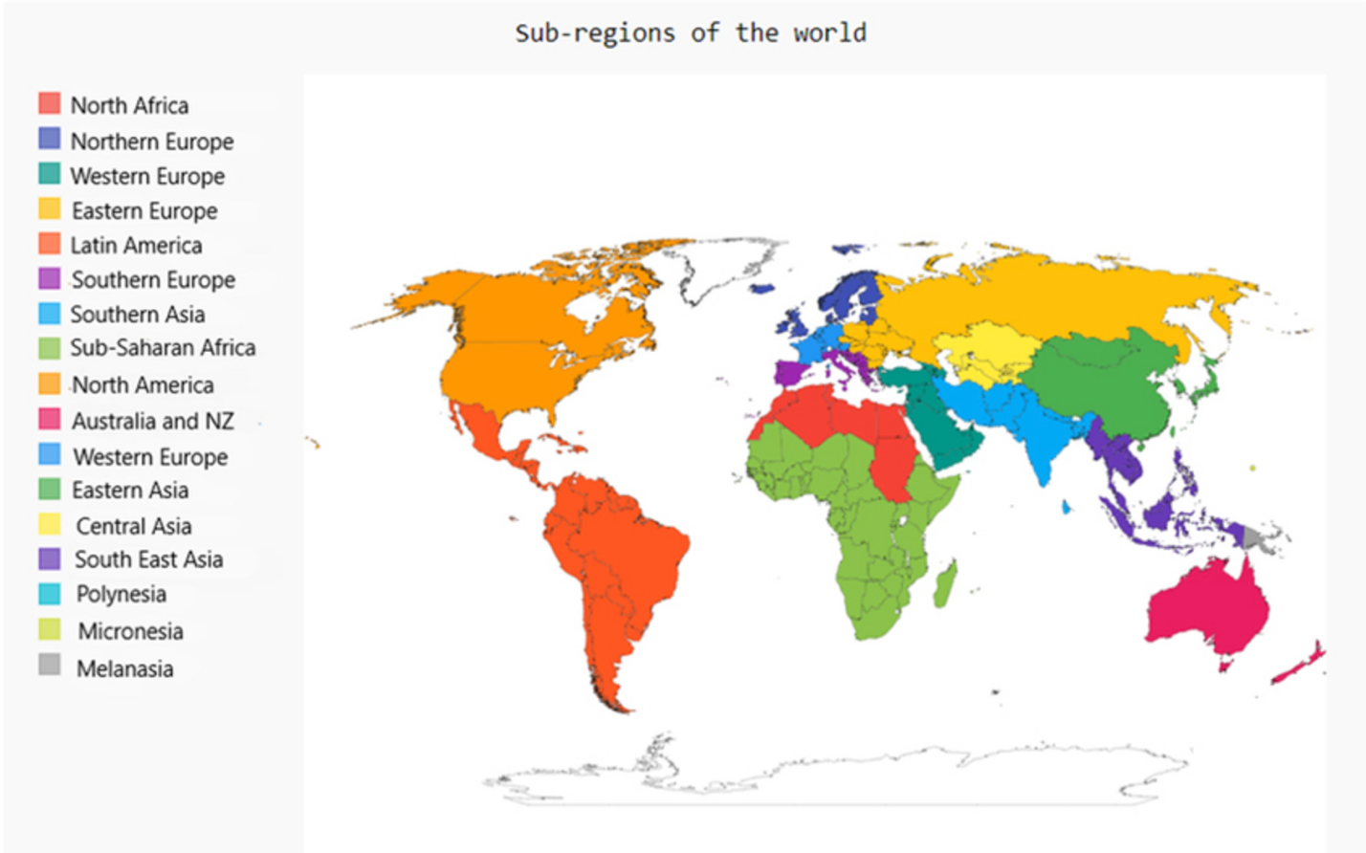

**Appendix C**

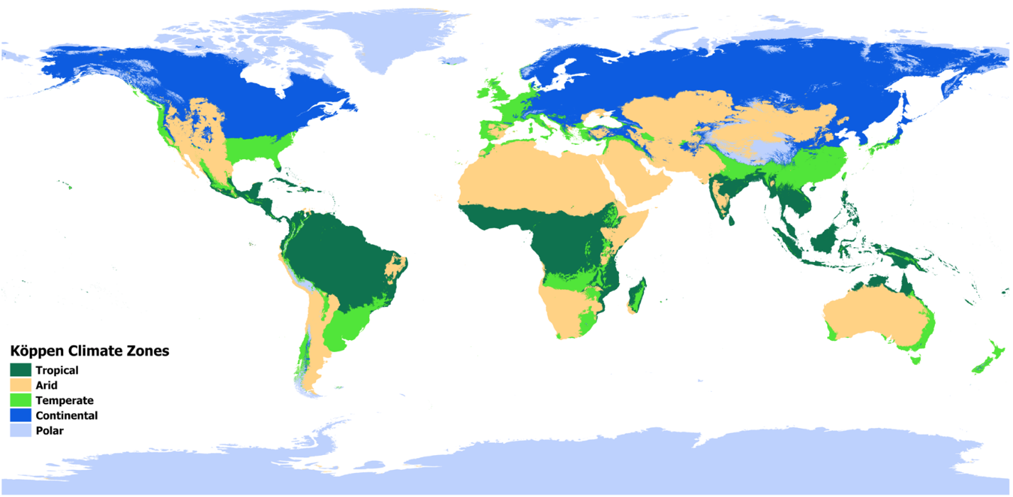

**Figures**

Carefully chosen and well-prepared figures, such as diagrams and photographs, can greatly enhance your article. You are encouraged to prepare figures that are clear, easy to read and of the best possible quality and resolution.

To make your figures accessible to as many readers as possible, try to avoid using colour as the only means of conveying information. For example, in charts and graphs use different line styles and symbols. Where colours are used try to ensure that:

* there is good contrast between adjacent colours;
* colours are distinguishable if the figure is converted to greyscale;
* different line styles, fill styles, symbols or labels are used in addition to different colours.

We accept that it is not always possible to follow these guidelines, for example with figures that use colour gradient scales to convey information, or for photographic images. As with all figures, it is important to use the figure caption to describe the information conveyed by the figure. See below for further details.

Figures are converted and sized to the journal template as part of the production process for accepted articles, but they are not normally edited further. It is your responsibility to ensure that the figures you supply are legible and technically correct.  
Characters should appear as they would be set in the main body of the article. Aim for text sizes of 8 to 12 pt at the final figure size: typically 8.5cm for a small/single-column figure and 15cm for a large/double-column figure. Micrographs should include a scale bar of appropriate size, e.g. 1 μm. Figures should be numbered in the order in which they are referred to in the text, using sequential numerals (e.g. figure 1, figure 2, etc.).

If there is more than one part to a figure (e.g. figure 1(a), figure 1(b), etc.), the parts should be identified by a lower-case letter in parentheses close to or within the area of the figure.

**File types**

For articles prepared using LaTeX2e, please make sure that your figures are all supplied as vector Encapsulated PostScript (EPS) and linked to your main TeX files using appropriate figure inclusion commands such as \includegraphics. For articles prepared using Word, where possible please also supply all figures as separate graphics files (in addition to being embedded in the text). Our preferred graphics format is EPS. These files can be used directly to give high-quality results, and file sizes are small in comparison with most bitmap forms.  
If you are unable to send us images in EPS, we can also accept:

* TIFF
* JPEG
* PDF (and images embedded within PDF files)
* Images/drawings coded using TeX/LaTeX package
* Images/figures embedded in MS Word, Excel or PowerPoint
* Graphics application source files (Photoshop, Illustrator, CorelDraw).

**Vector formats**

The advantage of vector graphics is that they give the best possible quality at all output resolutions. In order to get the best possible results, please note the following important points:

* Fonts used should be restricted to the standard font families (Times, Helvetica, Courier or Symbol).
* Certain proprietary vector graphics formats such as Origin, Kaleidagraph, Cricket Graph and Gnu Plot should not be sent in their native format. If you use these applications to create your figures, please export them as EPS.

**Figure captions**

Captions should be included in the text and not in the graphics files. Figure captions should contain relevant key terms and be self-contained (avoiding acronyms) so that a reader can understand the figure without having to refer to the text. To make your figures accessible to as many readers as possible, include the main points that the figure demonstrates in the caption. We provide further information and examples on [**this page**](https://publishingsupport.iopscience.iop.org/questions/example-figures/).